Metocean & Offshore Mission Analytics Initiative
Data Science Internship Scope Proposal
Objective
Develop a foundational offshore operational analytics capability to support Seagate Space mission planning, operational feasibility assessments, customer studies, and long-term development of offshore launch decision-support tools.
The internship effort will focus on collecting, organizing, analyzing, and visualizing historical metocean and environmental data relevant to offshore launch and recovery operations.

Phase 1 — Metocean Data Foundation
Objective
Develop a standardized offshore environmental database using publicly available maritime and weather datasets.
Potential Data Sources
- NOAA National Data Buoy Center (NDBC)
- NOAA WaveWatch III
- NOAA weather archives
- Copernicus or other marine data sources
Initial Scope  Identify select NOAA data buoys and obtain historical metocean data for each U.S. Coast Guard Captain of the Port (COTP) zone.  Depending on the size and operational relevance of the COTP zone, evaluate approximately 1–3 representative buoy locations, including:  - Inshore locations (closer to shore)  - Offshore locations (further offshore) | 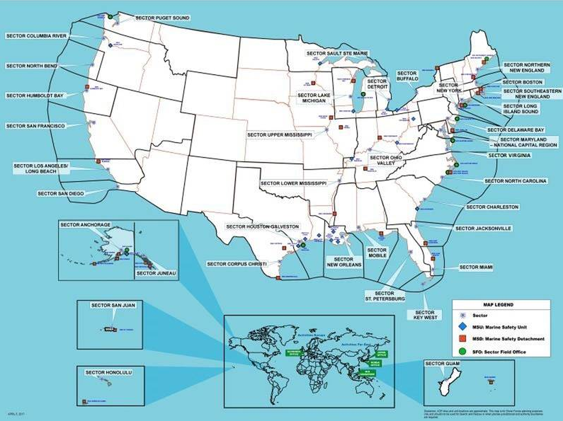
Core Data Parameters
Develop a structured database for:
- Sea state
- Significant wave height
- Swell period
- Wind speed and direction
- Weather windows
- Seasonal trends

Optional / Future Weather Parameters
Potential additional environmental conditions relevant to rocket launch operations may include:
- Hail probability
- Sustained wind thresholds
- Air temperature
- Precipitation
- Lightning activity
- Visibility
- Storm frequency / hurricane exposure
Deliverables
- Standardized metocean database
- Initial regional environmental summaries
- Buoy location mapping
- Historical sea-state trend datasets

Phase 2 — Operational Suitability Modeling
Objective
Use environmental datasets to evaluate offshore operational suitability and mission availability.
Example Analysis Areas
- Launch-capable days per year by region
- Frequency distribution of sea states
- Percentage of days exceeding operational thresholds
- Seasonal operational reliability trends
- Weather downtime estimates
- Comparative regional assessments
- Transit weather exposure analysis
- Candidate port suitability correlations
Example Operational Thresholds
Potential evaluation thresholds:
- Sea State ≤ SS3
- Sea State ≤ SS4
- Wave height limitations
- Wind limitations
Potential Outputs
- Launch availability scoring
- Monthly operational heat maps
- Regional operational comparison charts
- Launch window probability analysis
- Mission downtime estimates
- Environmental trend dashboards

Proposed Outcome & Strategic Value to Seagate
By completion of the internship effort, Seagate should possess:
- A foundational offshore metocean analytics capability
- Structured environmental and sea-state datasets
- Repeatable analytical workflows and operational suitability assessments
- Data-driven visualizations supporting mission planning, customer studies, and proposal development
- Enhanced technical credibility with customers, regulators, and partners

